JAZZ CAMPBELL

ACTRA

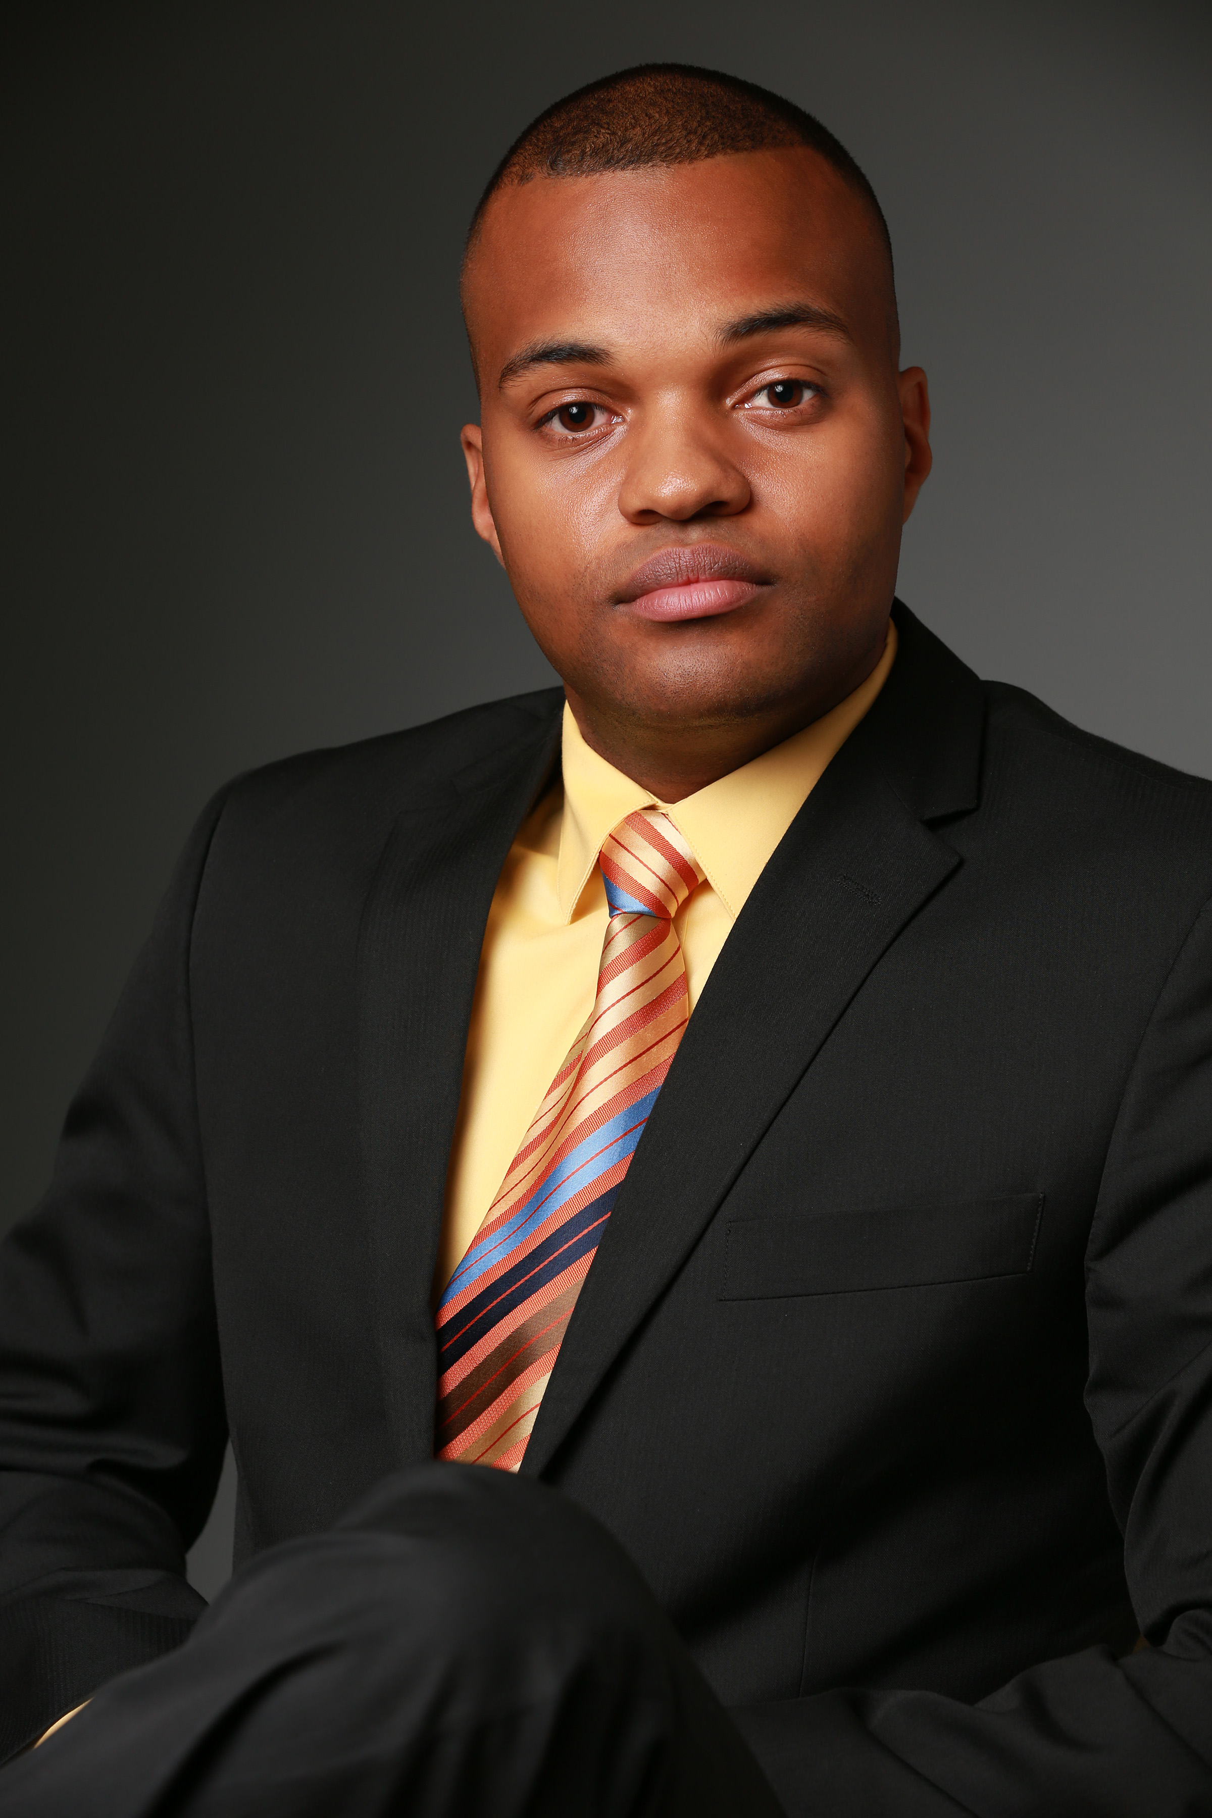
Height: 6’3”
Weight: 200 lbs.
Hair: Black
Eyes: Brown

FILM & TELEVISION

Haven Principal (William/S1;Ep 3) E1 Entertainment
Aspirations Principal (Deon/Short Film) Fortress Foundation
The Christmas Calendar Actor (Charlie) JN Productions

COMMERCIALS

Nova Scotia Tourism Principal Colour Inc.
Flow Jamaica Principal Curve Productions

EDUCATION

Victoria Academy of Dramatic Arts: Acting for Camera (1 year intensive 2017/2018)

Take 1: Adults in Film – Jacqui Kaese

Take 2: Advanced Class for Adults – Lynne Carrow

Advanced Scene Study – Bart Anderson

Voiceover Production Seminar – EarWorm Sound

Commercial Auditions – Kathleen Mayrs

Acting on Film – Master Class w/ Samuel L. Jackson

Casting Director Seminar – Kris Woznesensky

Career Development Program – Spotlight Academy
Bachelor of Arts: Acting – Dalhousie University
Radio and Television Arts – Radio Major Diploma (NSCC)

Acting for Film – John Dunsworth/Sheila Lane

SPECIAL SKILLS

Driving Military Vehicles (404s Driving License)

Break-dancing (16 years)

Popping (10 years)

Royal Canadian Navy Veteran (4 years)

Certified to operate RHIB and Zodiac boats

